Policies and Procedures Towards Ensuring Consistency in Accreditation Processes

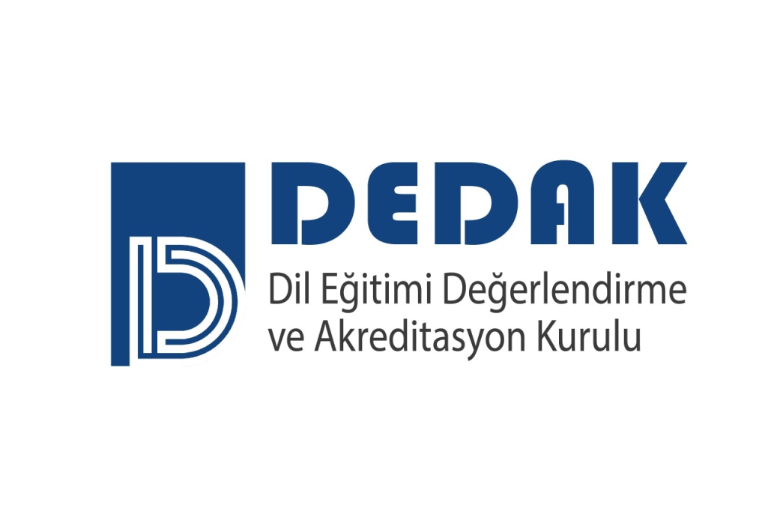
Association for Evaluation and Accreditation of Language Education Programs
E-mail : info@dedak.org
Web page : http://www.dedak.org
Phone: +90 212 311 6332

Policies and Procedures Towards Ensuring Consistency in Accreditation Processes

CONTENTS

ARTICLE 1- Grounds, Purpose and Scope 3
ARTICLE 2- Definitions and Abbreviations 3
ARTICLE 3- Responsibilities 3
ARTICLE 4- Election of the Chairperson and Members and their Terms of Office ……………………........3
ARTICLE 5- Consistency Policies 4
ARTICLE 6- Amendments 4
ARTICLE 7- Taking Effect 4
ARTICLE 8- Execution 4

Policies and Procedures Towards Ensuring Consistency in Accreditation Processes

Grounds, Purpose, and Scope
ARTICLE 1 - These procedures and principles have been prepared in accordance to the charter of the " Association For Evaluation and Accreditation of Language Education Programs (DEDAK)" , to the purpose of the said Association, to the 2nd article administering the operational policies and their formats that the Association chooses to pursue in order to attain its purpose, to the DEDAK directive on policies and procedures for evaluation and accreditation, to the article 8 that regulates the details of the evaluation process, and to article 13 that mandates consistency in the evaluation processes. Its purpose is to ascertain the procedures and principles to be followed for ensuring consistency and for increasing reliability regarding the accreditation process and results.

Definitions and Abbreviations
ARTICLE 2- In this directive, the terms below signify the following:
- DEDAK: Association for Evaluation and Accreditation of Language Education Programs,
- Board of Directors : board of Directors of DEDAK Yönetim Kurulu’nu,
- DAK: DEDAK Language Education Accreditation Board,
ç) Consistency Committee: The Committee that executes the consistency operations.

Responsibilities
ARTICLE 3- Activities to ensure consistency regarding DEDAK accreditation processes and reports are conducted at regular intervals. The Chairperson of the Board of Directors ensures that relevant policies are performed to establish consistency in DEDAK accreditation processes.

Election of the Chairperson and Members of the Consistency Committee and their Terms of Office
ARTICLE 4-
a) The Consistency Committee consists of a chairperson and at least four members. The chairperson of the Committee is elected primarily from among the members of the Consistency Committee who served before on the committee, if that is not possible, he/she will be appointed by the Board of Directors from among three candidates who undertook accreditation and quality assurance tasks, acted as the head of a DEDAK program evaluation team, and who are nominated by Language Education Accreditation Board (DAK) and will serve for two years.

b) Members of the Consistency Committee are selected from among three candidates who undertook accreditation and quality assurance tasks, preferably acted as the head or a member of a DEDAK program evaluation team, and who are nominated by Language Education Accreditation Board (DAK) with the approval of the Board of Directors and will serve for two years.

c) The chairperson and members of the Consistency Committee, whose terms have expired, may be reinstated, but the chairperson of the Committee cannot serve for more than two terms.

Consistency Policies
ARTICLE 5-
a) Consistency Procedures Performed by the Evaluation Team Prior to Visiting an Institution
(1) Prior to a visit to an institution, the head of the evaluation team (DTB) and the members (DTÜ) study the self-evaluation report of the institution and contrive a preliminary evaluation according to the provisions specified in DEDAK Evaluation Guide. In this evaluation, DTB and DTÜ express their opinions openly and clearly, and by reconciling the differences, consistency in the opinions of the evaluation team regarding the self-evaluation report is ensured.
b) Consistency Protocol Performed by the Evaluation Team After Visiting the Institution
(1) Following the visit to the institution, DTB ensures the active participation of DTÜ’s by holding a meeting in which the opinions expressed in the report are compared, the agreements/divergences are identified, and the terminology is standardized.
(2) After the examining the report from a consistency perspective and for possible modifications, DTÜ meets with DTB to finalize it. The final version is relayed to DAK by DTB.
c) Application of the Consistency Protocol to the Evaluation Report of the Institution by Consistency Committee (TK)
(1) The head of the Consistency Committee (TKB) assigns to two members of the Consistency Committee (TKÜ) the task of assessing the consistency of the evaluation report for accreditation of the pertinent institution and distributes the evaluation report of the institution sent by DAK to relevant members.
(2) The two members, assigned with the task of examining the consistency of the report according to the DEDAK Evaluation Guidelines, conduct their examinations independently.
(3) Following the individual investigations, the members of the TK meet to mediate discrepancies in consistency with the purpose of reaching a concensus.
(4) After reaching a concensus and performing the necessary rectifications regarding consistency, the TKÜ report is submitted to the TKB.
(5) Ensuing the verification of the report, TKB forwards it to DEDAK offices for language control. Subsequent to this process, the report is delivered to DAK.
ç) Protocol executed by the Consistency Committee (TK) for ensuring consistency among the evaluation teams
(1) The head of the Consistency Committee (TKB) randomly selects three reports prepared within the same period by different evaluation teams and controlled by the Consistency Committee (TK) , and ensures that the task of controlling their consistency is completed within 30 days by two members of the Consistency Committee (TKÜ) that the TKB designates.
(2) The designated members of the Consistency Committee (TKÜ), convene after completing their investigations and focus on discrepancies in the reports on consistency with the purpose of reaching a concensus. Their report bearing an unanimous outcome on discrepancies is sent to TKB.
(3) The report prepared by the relevant members of the Consistency Committee (TKÜ) is sent to DAK by TKB.
d) Procedures performed by the Consistency Committee for safeguarding consistency through the years
(1) TKB, during the last quarter of each year randomly selects two reports prepared by separate evaluation teams in the previous year and two of the current year and ensures that consistency controls are completed within 30 days by designated two members of TKÜ.
(2) The designated members of the Consistency Committee (TKÜ), convene after completing their investigations and focus on discrepancies in the reports on consistency with the purpose of reaching a concensus. Their report of an unanimous outcome on discrepancies is sent to TKB.
(3) The report prepared by the relevant members of the Consistency Committee (TKÜ) is sent to DAK by TKB.
e) Amendments to be made towards securing consistency during the evaluation process
At the beginning of each year, a meeting is held with the purpose of securing consistency in the evaluation processes by DAK with the participation of TKB. In this meeting, the reports assessing consistency among the teams and consistency throughout the years are considered and evaluated. And if deemed necessary, proposals regarding amendments to such resources as DEDAK Evaluation Guidelines and similar documents and to evaluative training program are conveyed to the Board of Directors.

Amendments
ARTICLE 6-
- If deemed necessary, amendments regarding Policies and Procedures Towards Ensuring Consistency in Acreditation Processes are prepared by a committee appointed by the Board of Directors are presented to the Board of Directors. The proposals thus prepared are put on the agenda of the earliest meeting of the Board and are resolved.

Taking Effect
ARTICLE 7-
- This Policies and Procedures takes effect on the date it is appoved.
Execution
ARTICLE 8-
- This Policies and Procedures is executed by the chairperson of the Board of Directors.

