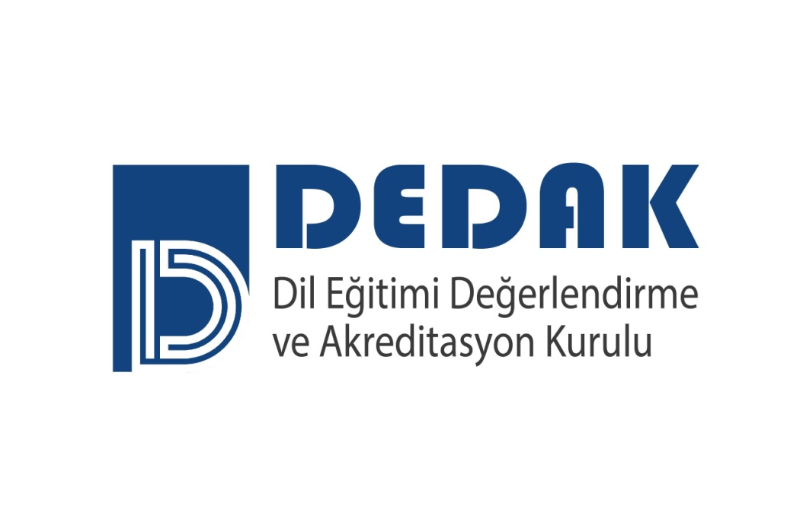

**DEDAK REVIEWER APPLICATION FORM**

|  |  |  |  |
| --- | --- | --- | --- |
| Name-Last name/  Email address: |  | Phone: |  |
| Institution/Program: |  | | |
| Position at Institution: |  | | |
| Application Date: |  | | |

**Please provide the requested information below under the appropriate area.**

**Please send this form along with your CV and letter of intent by 30 May 2025 at the latest to** [**info@dedak.org**](mailto:info@dedak.org)**.**

1. Academic qualifications (please summarize).
2. List the professional bodies and associations you are a member of with a short explanation.
3. Describe past and/or present managerial roles/administrative duties you have undertaken.
4. State the professional development activities you have participated in in the last 5 years.
5. Briefly state all studies and experiences you have connected to Program Evaluation/Consulting, Accreditation and Quality Assurance.
6. Provide two professional references (name and contact information) with at least one of them from your institutional manager.

I affirm that all the information that I have provided in this form is correct.

Name-Last name

Signature